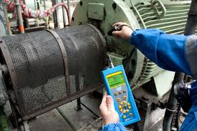  Introduction of Condition Monitoring as part of Reliability Focused Asset Management.  29th September 2016  In co-operation with the  HO CHI MINH CITY UNIVERSITY OF TECHNOLOGY AND EDUCATION (HCMUTE)  This event will explain the importance of the Condition based Maintenance concept to increase the overall productivity of a manufacturing facility. This seminar will present:  - INTRODUCTION TO CONDITION MONITORING  - A BRIEF INTRODUCTION OF RELIABILITY FOCUSED ASSED MANAGEMENT (RFAM)  - CASE STUDY OF HOW A COMPANY SAFED 25% ON MAINTENANCE COST  - INTRODUCTION TO A LOCAL TRAINING CONCEPT FOR CONDITION MONITORING ENGINEERS  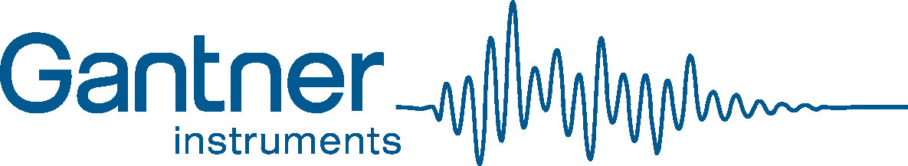 |  | INCREASE PRODUCTIVITY  REDUCE UNSCHEDULED MAINTENANCE SHUT DOWNS  IMPROVE PLANT RELIABILITY  CONDITION MONITORING TRAINING  venue  Conference room No. 2  6th floor, main building  HCMC University of Technology and Education  No. 1 Vo Van Ngan Str., Thu Duc Dist., HCM City  29th Sept. 2016  13:30pm – 17pm  Gantner Instruments (SEA)  27 West Coast Highway #02-22  Singapore 117 867  www.gantner-instruments.com

REGISTRATION FORM

Name: _______________________________________________________
Company: _______________________________________________________
Position: _______________________________________________________
Address: _______________________________________________________
Phone: _______________________________________________________
E-mail: _______________________________________________________

For any further question please call:
Eng. Tran Trong Nghia at
E-mail: hoangquochhcm@hoangquoc.com
Phone: (84-3) 39317180

Dr. Hoang Trung Kien at
E-mail: kienhtr@hcmute.edu.vn
Phone: (84) 906128993

